
Symbiosis Institute of Technology, Pune
Faculty of Engineering
CSE- Academic Year 2026-27
Java Programming – Lab Batch 2025-29
Lab Assignment No:- 23
Name of  Student | Aniruddha Pratap Singh
PRN No. | 25070122247
Batch | CSE-C
Class | PROGRAMMING WITH JAVA
Academic  Year &  Semester | 2nd-year and 3rd-semester
Date of  Submission | 04/10/2026
Title of  Assignment: | Develop a Java application using JDBC to navigate and retrieve records from a ResultSet.
Problem  Statement | Develop a Java application using JDBC to navigate and retrieve records from a ResultSet.
Learning  objective | To navigate and retrieve records using ResultSet methods.
Theory | A ResultSet object contains data retrieved from a database after executing a SELECT query. It acts like a cursor that points to one row of the result at a time. Initially, the cursor is positioned before the first row. Various methods  such as next(), previous(), first(), last(), absolute(), and relative() allow movement through the records. Data from each column can be retrieved using methods like getString(), getInt(), and getDouble(). Scrollable and updatable ResultSets provide greater flexibility for navigating

 | and modifying retrieved data. ResultSet plays a crucial role in displaying and processing database information in Java applications.
Programme | 1. Create a program to display database records one by one using ResultSet. =>import java.sql.*;  public class E1 {  public static void main(String[] args) {  String url = "jdbc:mysql://localhost:3306/jdbc_demo";  String user = "root";  String password = "YOUR_MYSQL_PASSWORD";  try {  // Load JDBC driver  Class.forName("com.mysql.cj.jdbc.Driver");  // Connect to database  Connection con = DriverManager.getConnection(  url, user, password  );  System.out.println("Database connected successfully.\n");  // Create Statement  Statement stmt = con.createStatement();  // Execute SELECT query  String query = "SELECT * FROM records";  ResultSet rs = stmt.executeQuery(query);  System.out.println("Records:");  // Navigate through ResultSet one by one  while (rs.next()) {  System.out.println(  "ID: " + rs.getInt("id")  + ", Name: " + rs.getString("name")  + ", City: " + rs.getString("city")

);
}
// Close connection
con.close();
} catch (Exception e) {
System.out.println("Error: " + e.getMessage());
}
}
}
2. Create a Java program that retrieves employee records from a database and displays them one by one using ResultSet. Show employee ID, name, department, and salary sequentially
=>
import java.sql.*;
public class E2 {
public static void main(String[] args) {
String url = "jdbc:mysql://localhost:3306/jdbc_demo";
String user = "root";
String password = "YOUR_MYSQL_PASSWORD";
try {
// Load JDBC driver
Class.forName("com.mysql.cj.jdbc.Driver");
// Connect to database
Connection con = DriverManager.getConnection(
url, user, password
);
System.out.println("Database connected successfully.\n");
// Create Statement
Statement stmt = con.createStatement();
// Execute SELECT query

String query = "SELECT * FROM employee23";
ResultSet rs = stmt.executeQuery(query);
System.out.println("Employee Records:");
// Navigate through records one by one
while (rs.next()) {
System.out.println(
"Employee ID: " + rs.getInt("id")
+ ", Name: " + rs.getString("name")
+ ", Department: " + rs.getString("department") + ", Salary: " + rs.getDouble("salary")
);
}
// Close connection
con.close();
} catch (Exception e) {
System.out.println("Error: " + e.getMessage());
}
}
}
SQL:
CREATE DATABASE IF NOT EXISTS jdbc_demo;
USE jdbc_demo;
-- =========================
-- E1: RECORDS TABLE
-- =========================
DROP TABLE IF EXISTS records;
CREATE TABLE records (
id INT PRIMARY KEY,
name VARCHAR(50),
city VARCHAR(50)
);

INSERT INTO records VALUES
(1, 'Rahul', 'Pune'),
(2, 'Amit', 'Mumbai'),
(3, 'Priya', 'Nashik'),
(4, 'Rohit', 'Delhi');
-- =========================
-- E2: EMPLOYEE TABLE
-- =========================
DROP TABLE IF EXISTS employee23;
CREATE TABLE employee23 (
id INT PRIMARY KEY,
name VARCHAR(50),
department VARCHAR(50),
salary DOUBLE
);
INSERT INTO employee23 VALUES
(101, 'Rahul', 'CSE', 40000),
(102, 'Amit', 'IT', 45000),
(103, 'Priya', 'HR', 42000),
(104, 'Rohit', 'Finance', 50000);
-- Check records
SELECT * FROM records;
SELECT * FROM employee23;

Output  Screenshots  (if applicable) | E1 =>  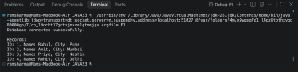

E2 =>
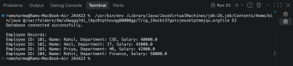
Github  Screenshot | 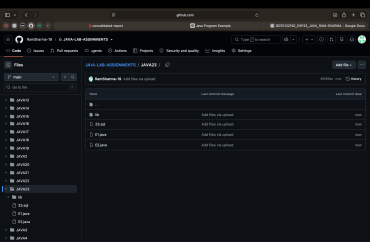
Conclusion | In this assignment, JDBC ResultSet was used to retrieve and navigate database records. The next() method was used to move through the records one by one. The required employee details such as ID, name, department, and salary were successfully retrieved using getInt(), getString(), and getDouble(). The experiment helped in understanding how data returned by a SQL SELECT query can be accessed sequentially in Java.

